Project Statement

1. COMPANY PROFILE
   1. About

Resources for the Blind Inc. is a non-profit and non-government Christian organization that serves the visually-impaired people since 1988. They devoted themselves in removing the obstacles and providing services, trainings, and equipment needed in order for those who are visually-impaired to reach their fullest potential in life.

* 1. Mission

To design and implement programs that will enable those with visual impairment to understand and reach their God-given potential in life and service.

* 1. Vision

All Filipinos who are visually impaired will be able to reach their fullest potential in life and in ministry that God has for them.

* 1. Board of Trustees

|  |  |
| --- | --- |
| Name | Position |
| Lemuel A. David Salmo | President |
| Nora G. Lucero | Vice President |
| Amelia M. Torrente | Secretary |
| Damiana D. Exiomo | Treasurer |
| David D. Gutierrez | Auditor |

1. CONTACT INFORMATION

|  |  |  |
| --- | --- | --- |
| Name | Role | Contact Information |
| Trasmonte, Marie Kathleen A. | Project Manager | matrasmonte@apc.edu.ph  mkat_11@yahoo.com |
| Hocosol, Liza B. | Documenter  Programmer | lbhocosol@apc.edu.ph  lbhocosol@gmail.com |
| Olalo, Christine Mae V. | Documenter  Programmer | cvolalo@apc.edu.ph  christinemaeolalo@gmail.com |

1. STAKE HOLDERS

|  |  |
| --- | --- |
| Name | Position |
| Marie Kathleen A. Trasmonte | Project Manager |
| Liza B. Hocosol | Documenter  Programmer |
| Christine Mae V. Olalo | Documenter  Programmer |
| Ms. Maria Teresa Carmela Montemayor | Project Adviser  *Asia Pacific College*  E-mail: tessm@apc.edu.ph |
| Mr. Jose Eugenio Quesada | Professor  *Asia Pacific College*  E-mail: jlquesada@apc.edu.ph |

1. USERS

The target user is the sales coordinator of the organization. RBI hires not just people with normal eye sight but also visually-impaired that’s why the system is expected to compensate for the user’s disability.

1. PROJECT OBJECTIVES
   1. Short Term
2. Improved files or records accessibility

The system would have a database where the user would easily access the product, sales, supplier and customer information. This would replace the hassle of manually adding, updating, and deleting of records.

1. More convenient item tracking and retrieval

In the database, the user would easily keep track of the number of available and out-of-stock items. The addition (when new items arrive) and deduction (whenever customers buy) would immediately reflect in the database. The donated, bought, and defected materials would also be identified by the system. Furthermore, the retrieval of past records would be attained without ado.

1. Make work more efficient and effective

With the help of the system, the user would get the work done faster and there won’t be any wasted resources (e.g. time, effort, energy).

1. Monitor transactions easily

The sales coordinator would easily keep track of every customer transactions through the system which would help to know the day-to-day sales of the organization making it less taxing.

* 1. Long Term

1. Auto-generation of accurate and precise monthly and annual sales and inventory report

Having all transaction and item records stored in the database included in the system would generate a report where the user could see the monthly and annual sales trend of the organization.

1. Blind and visually-impaired friendly interface

The system’s interface would not be hard to manipulate even if the user is either blind or visually-impaired. As much as possible, controlling the system would be done with the use of the tab key, arrow keys, and buttons with labels.

1. SUCCESS FACTORS

The project will be deemed successful if the following objectives have been met:

* 1. Short Term

1. Improved accessibility and availability of records
2. Increased work efficiency
3. Fast record retrieval and precise item information
4. The project was able to resolve all issues encountered by the staff in-charge.
   1. Long Term
5. The system may be used for a long period of time.
6. Accurate and precise monthly and annual reports
7. Applicable for all people with different types of eye defects
8. Embodied the organization’s stewardship value for check-and-balance of resources entrusted to the organization.

Vision and Scope

1. BUSINESS REQUIREMENTS
   1. Background, Business Opportunity, Customer Needs

Selling assistive devices for the visually impaired and low vision individuals is one of Resources for the Blind Inc.’s offered service. Most of the devices they sell are imported since there are some that aren’t locally available. The sales coordinator searches for new assistive devices over the Internet and look for suppliers who could supply them. The existing items would be provided by those who supplied it before. Before placing the order, they would inquire if the said item is still available. If it is, they would request a quotation, which would be approved by the RBI heads. The purchasing and payment of the order would be done after the approval. The pricing of the items are done by the accounting department. They usually add 15% or 20% mark-up for the repair or some overhead expenses of the item.

As per the request of the sales and purchase department, an inventory system that could monitor its daily sales transaction and replace its current manual system of managing in-stock devices would be the most feasible solution. This system could help the sales and purchase staff save time since counting and computing manually would be a big hassle.

* 1. Business Objectives and Success Criteria

|  |  |
| --- | --- |
| BO-1 | Accurately generate monthly and annual sales reports. |
| BO-2 | Increase efficiency of keeping track of the sales and day-to-day transaction by 50% within three months of usage. |
| BO-3 | Present data or records with precision |
| BO-4 | Easily tracking and retrieving of records |
| SC-1 |  |
| SC-2 |  |

* 1. Business Risks

|  |  |
| --- | --- |
| BR-1 | May not be considered visually impaired-friendly depending on whether the user has normal eyesight or is visually impaired. |
| BR-2 | May require the user a longer time to be familiar with the system. |
| BR-3 | The system might be too complicated for the user to understand. |

1. VISION OF THE SOLUTION
   1. Vision Statement

The proposed inventory system could monitor the daily purchasing transactions of the organization, from the customers to the sales and purchase department. It should also generate a monthly and annual sales report. In addition to these, there should be a list of existing suppliers for easier order inquiry and a list of customers for keeping track of who is always availing the items they sell. Since the organization also hires visually-impaired and low vision employees, the system should also be simple and easy to use. The use of too many buttons is discouraged. If possible, the inventory would be accessed with the use of arrow buttons and tab button. With the help of a screen reader, visually-impaired employees are able to use computers, so if the use of buttons won’t be avoided, there should be labels present in each of it. Currently, the sales and purchase department doesn’t have an existing system. They do everything manually; from counting the in-stock devices to computing the amount of every ordered items. Because of this, all the people who held the position as the sales and purchase head had different ways of keeping track of all the records.

* 1. Major Features

|  |  |
| --- | --- |
| FE-1 | User log in |
| FE-2 | Add, view, modify, search, and / or delete list of available items |
| FE-3 | Add, view, modify, search, and / or delete list of customers |
| FE-4 | Add, view, modify, search, and / or delete list of suppliers |
| FE-5 | Automatic addition and deduction in the number of available items |
| FE-6 | Displays a warning message whenever the item stocks are about to run out |
| FE-7 | Generates a daily total of sold items |
| FE-8 | Monitors day-to-day customer transactions |
| FE-9 | Generates monthly and annual sales trend reports |

* 1. Assumptions and Dependencies

|  |  |
| --- | --- |
| AS-1 | The user is knowledgeable about the system. |
| AS-2 | A computer or laptop is available for the utilization of the system. |
| AS-3 | The user regularly checks the records to ensure data integrity. |
| DE-1 | The system could only be viewed using a web browser (e.g. Mozilla Firefox, Google Chrome, Safari etc.). |
| DE-2 | If the user is blind or visually impaired, there would be a need of using a screen reader to read the labels found in the system. |

1. BUSINESS CONTEXT

9.1. Stakeholder Profiles

|  |  |  |  |  |
| --- | --- | --- | --- | --- |
| Stakeholder | Major Value | Attitudes | Major Interests | Constraints |
| Sales Coordinator,  Resources for the Blind Inc. | Managing and encoding of sales and product list | Efficient at work and hard working | Accurate and precise database records, improved efficiency at work | He / she should be knowledgeable about the system. |

1. EVENT TABLE

|  |  |  |  |  |  |
| --- | --- | --- | --- | --- | --- |
| Event | Trigger | Source | Activity / Use Case | Response | Destination |
| Customer wants to check item availability | Item Inquiry | Customer | Customer Inquiry / Look-up Item Availability | Item availability details | Sales coordinator |
| Sales coordinator checks the item availability from the inventory | Inventory Item Check | Sales coordinator | Look-up Item Availability | List of available items | Sales coordinator |
| Sales coordinator informs the customer if the item is available | Available Items Price List | Sales coordinator | Look-up Item Availability | Sends the available items price list to the customer | Customer |
| Customer purchases an item | Item Purchase | Customer | Purchase Item/s | Sales coordinator processes the inquiry. | Sales coordinator |
| Customer fills out purchase form | Purchase Confirmation | Customer | Purchase Item/s | Customer information and details about the item purchased | Sales coordinator |
| Sales coordinator generates payment details to be forwarded to the Accounting | Payment Details | Sales coordinator | Payment Details | Payment details are received by the customer | Customer |
| Sales coordinator updates customer record | Customer Records Update | Sales coordinator | Customer Records Update | Updated customer record | Sales coordinator |
| Sales coordinator updates item inventory | Inventory Update | Sales coordinator | Inventory Update | Updated item inventory | Sales coordinator |
| Customer inquires about returning and replacing a defective item | Item Inquiry | Customer | Customer Inquiry; Defective Items | Terms of condition and warranty details | Sales Coordinator |
| Sales coordinator checks if the item is possible for return or replacement | Item Inquiry | Sales coordinator | Defective Items | Sales coordinator tells the customer if it is possible or not | Customer |
| Customer wants to return or replace a defective item | Inventory Update | Customer | Defective Items; Inventory Update | Updated item inventory | Sales Coordinator |
| Sales coordinator receives arrivals of ordered items from previous and new suppliers and / or item donations | Inventory Update | Supplier / Donor | Inventory Update | Updated item inventory | Sales Coordinator |
| Generate sales report | Sales Report | Sales Coordinator | Sales Report | The sales coordinator submits the monthly and annual sales report to the organization | Organization |

1. USE CASES
   1. Brief Format
2. Customer Inquiry

The customer inquires about anything he or she wants to know about the items sold by the organization, terms of condition, warranty details, defective item rules, etc. The inquiry is processed by the sales coordinator.

1. Look-up Item Availability

The sales coordinator checks the availability of the item specified by the customer in the inventory. If the item is out-of-stock, it would only display the available items. The sales coordinator would suggest a somehow similar item to customer if the specified item isn’t available. It would be up to the customer if he / she would avail it.

1. Purchase Item/s

Once the customer decided to buy his / her specified item (or if he / she decided to buy the suggested item), he / she would fill up the purchase form that would prove that the sales coordinator acknowledges the purchase.

1. Payment Details

After filling up the purchase form, the payment details (item prices, item quantities, mode of payment, purchase date, etc.) would be generated. This payment details would be forwarded to the accounting office where an invoice would be generated.

1. Customer Records Update

The customer data from the purchase form are encoded to the customer records where all the information about all the people who purchased something from RBI can be found. This is a way to keep track of how many times a customer bought something from the organization and how long it took them to buy the same or another item.

1. Item Return / Replacement

Defective items purchased by the customers could be returned or replaced. Before these items can be approved for replacement or return, they should first be able to satisfy the terms of condition for return and replacement. Once the request is granted, the returned item would be added to the number of items in the inventory although it would be labeled as defective and it would not be sold anymore.

1. Inventory Update

The sales coordinator updates the item inventory upon the customers purchase. The number of available items would change depending on how many items were sold.

1. Sales Report

The system would generate monthly and annual sales reports showing the sales trend of the organization.

* 1. Casual Format

1. Look-up Item Availability

Main Success Scenario:

The sales coordinator looks for the item specified by the customer in the system’s inventory and checks if it is available for purchase.

Alternate Scenarios:

* If the specified item is out-of-stock, the customer would have to wait for the next batch of items to arrive. Since RBI allows neither pre-order of items nor reservation, the customer must inquire again if he / she still want to buy the item.
* The sales coordinator looks for alternative items that almost have the same functionality as the one that the customer was looking for and suggests that he / she could just purchase it instead of the one out-of-stock.

1. Purchase Item/s

Main Success Scenario:

The customer purchases an item. The sales coordinator would give a purchase form to the customer for him / her to fill-out. The data from the filled-out purchase form are needed to keep track of the customer’s purchase records and to see how much does the item cost.

Alternate Scenarios:

* If the customer decides to add more items to his / her purchase, he / she should immediately tell the sales coordinator about it before the payment detail is released.

1. Payment Details

Main Success Scenario:

The payment details are given to the customer after processing what item was purchased, how many items are purchased, how much it costs, payment method, etc. After receiving the payment details, it is forwarded to the accounting and the customer pays for his / her purchase. The customer receives the invoice from the accounting.

Alternate Scenarios:

* If the customer is about to pay for his / her purchases and realizes that he / she doesn’t have enough money, the item purchase would be cancelled. Since reservation isn’t allowed, the customer would have to go through the purchasing process again once he come back to get money.

1. Customer Records Update

Main Success Scenario:

The customer information would then be added to the customer records.

Alternate Scenarios:

* If there is an existing record of the customer, the purchased item information would just be added to the existing record.
* If there is an existing record of the customer but some of her current record does not match the ones found in the existing record (e.g. new address), the sales coordinator would just update the existing and add the purchased item.

1. Defective Items

Main Success Scenario:

The customer asks for an item return and replacement with a new one or a different one. Her request would be processed by the sales coordinator. RBI does not allow money refund that is why the returned item would only be replaced. The defective item would just be added to inventory item but it would be labeled as defective. It would be a loss in the organization. They would not be able to immediately repair the item since it takes a long time for the supplier to respond to the organization’s request for fixing considering most of the items are imported.

Alternate Scenarios:

* If it took the customer a long time to inform the sales coordinator about the defective item he / she purchased, the return and replacement of the item wouldn’t be possible anymore. It would be subjected to repair if the customer was able to inform the sales coordinator within the covered time of the warranty. Although, it usually takes a month or so especially if the item was imported.
* If a customer purchased an item with incomplete add-ons (e.g. talking watch without batteries), the organization would be the one to replace those missing. The budget for these would be charged from the organization’s funds resulting to their loss.

1. Inventory Update

Main Success Scenario:

The sales coordinator updates the item inventory. He / She would add, view, modify, and / or delete from the list depending on the situation: a customer purchases an item, ordered items and / or new items from different suppliers (previous / new) arrive, a customer returns and / or replaces an item, whenever people donate items, price change, items run out of stocks, etc.

Alternate Scenarios:

* If the sales coordinator encounters a problem in updating the inventory, he / she should immediately troubleshoot the system or ask someone for assistance.

1. Sales Report

Main Success Scenario:

The system generates the monthly and annual report containing the sales trend. This report is sent to the accounting and marketing office.

Alternate Scenarios:

* If the accounting and marketing head wants to ensure that the report is accurate, they could manually tally the number of sold items with the help of the sales coordinator.
  1. Fully-dressed Format

1. Look-up Item Availability

Primary Actor: Sales Coordinator

Stakeholder & Interests:

* Sales Coordinator
* Searches the inventory for the items available and its details
* Checks if the requested item/s by the customer is available or not and gets the details about the item/s
* Customer
* Inquires if the needed item is available
* Needs the item details in order for his/her to purchase it

Preconditions: The sales coordinator needs to be logged in the system.

Success Guarantee (Post-conditions): The sales coordinator successfully logged in the system. Every transaction will be recorded and updated to the system. The sales report will be generated by the system monthly and annually.

Main Success Scenario (Basic Flow):

|  |  |
| --- | --- |
| Actor Intention | System Responsibility |
| 1. The sales coordinator asks the item needed by customer |  |
| 1. He checks the inventory if the requested item is available | 1. The system will list the available items with its details |
| 1. He informs the customer if the item is available and provides the details about it. |  |

Extensions (Alternative Flow):

1. If the system fails, the sales coordinator needs to restart the system.
2. If the item entered is incorrect or misspelled, the system will generate an error message that notifies the sales coordinator.
3. If the searched item is not found in the system, the system will generate an error message and informs the customer that the item is not available.

Special Requirements:

* Database System
* Database Server

1. Inventory Update

Primary Actor: Sales Coordinator

Stakeholder & Interests:

* Sales Coordinator
* Needs the updated item inventory (after the addition and deduction of item count)
* Customer
* Wants to replace or return a certain item/s

Preconditions: The sales coordinator needs to be logged in the system.

Success Guarantee (Post-conditions): The sales coordinator successfully logged in the system. Every transaction will be recorded and updated to the system. The sales report will be generated by the system monthly and annually.

Main Success Scenario (Basic Flow):

|  |  |
| --- | --- |
| Actor Intention | System Responsibility |
| 1. The sales coordinator inputs the number of deducted items (when a customer purchases or returned) or the number of added items (when there are newly-arrived items). | 1. The system will process and automatically updates the item count of a specific item. Also, it will display the newly-updated inventory. |

Extensions (Alternative Flow):

1. If the system fails, the sales coordinator needs to restart the system.
2. If the number of items inputted by the sales coordinator is greater than the number of total items or has not entered any value, the system will display an error message.

Special Requirements:

* Database System
* Database Server

1. ACTIVITY DIAGRAM

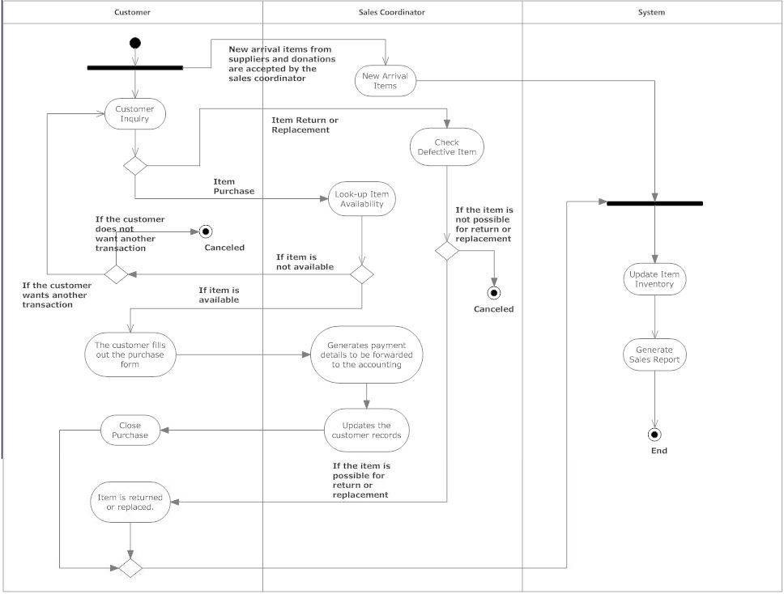

1. Database Design
   1. Entity Relationship Diagram

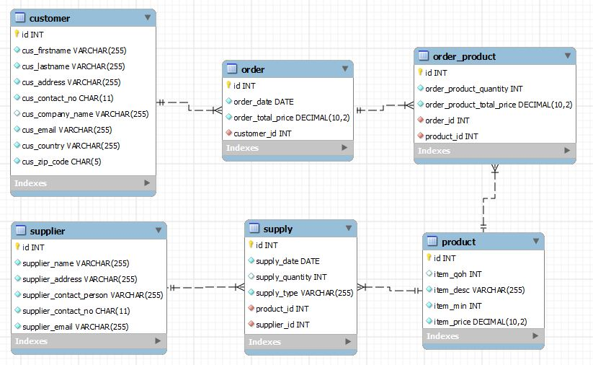

* 1. Data Dictionary

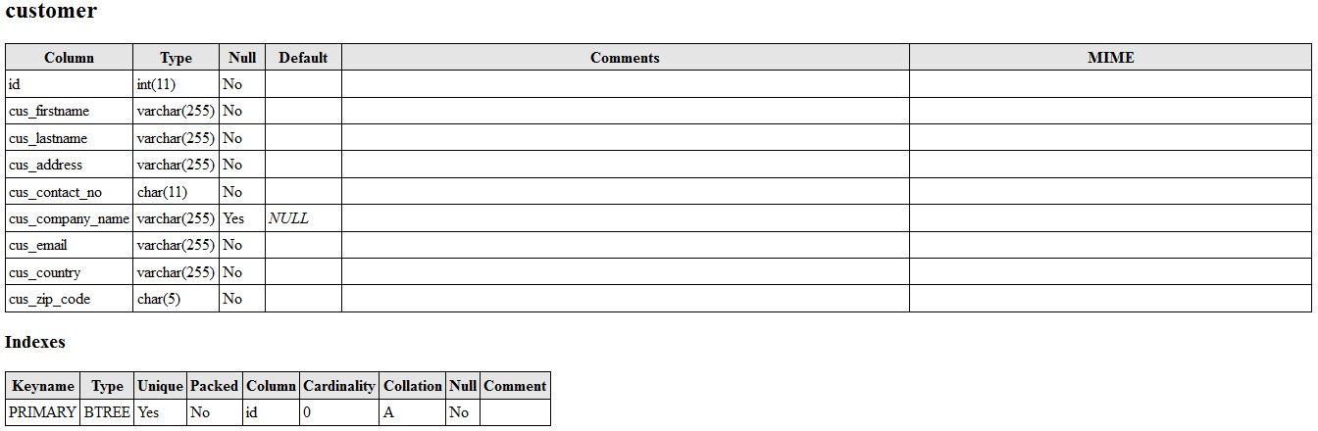

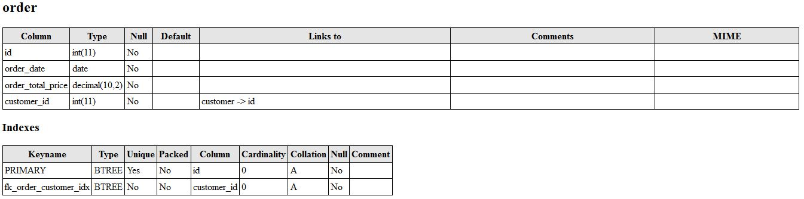

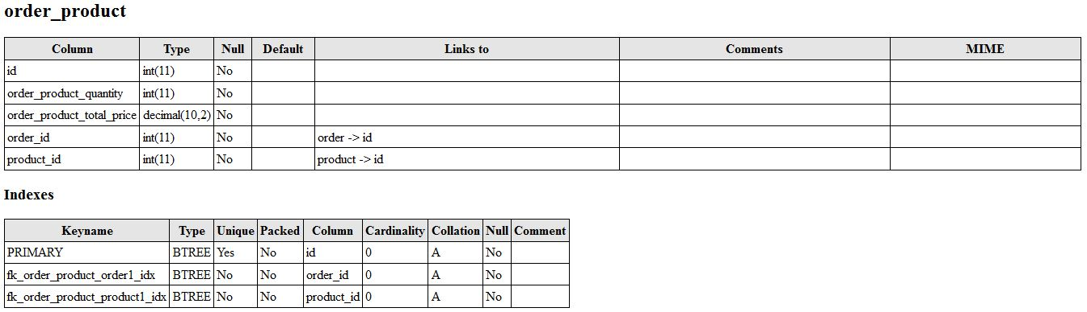

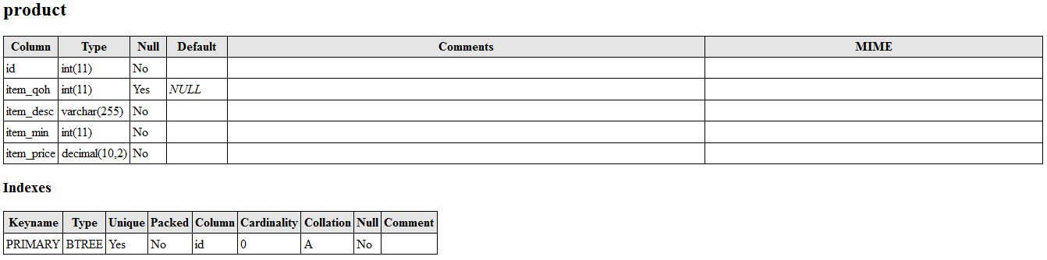

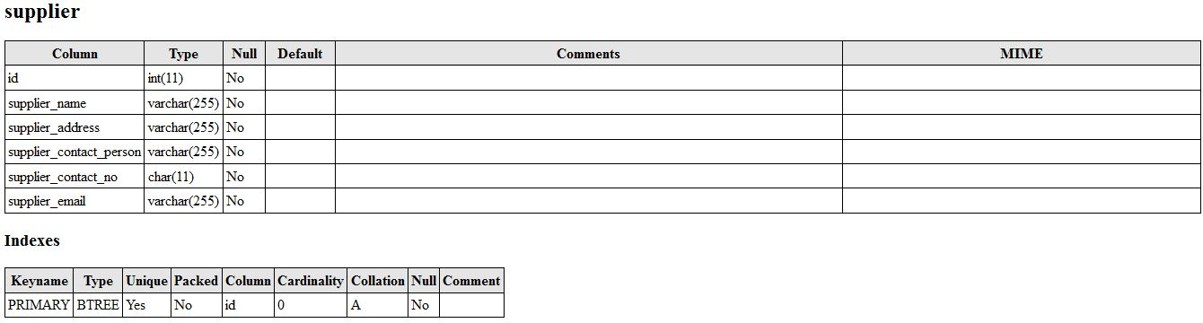

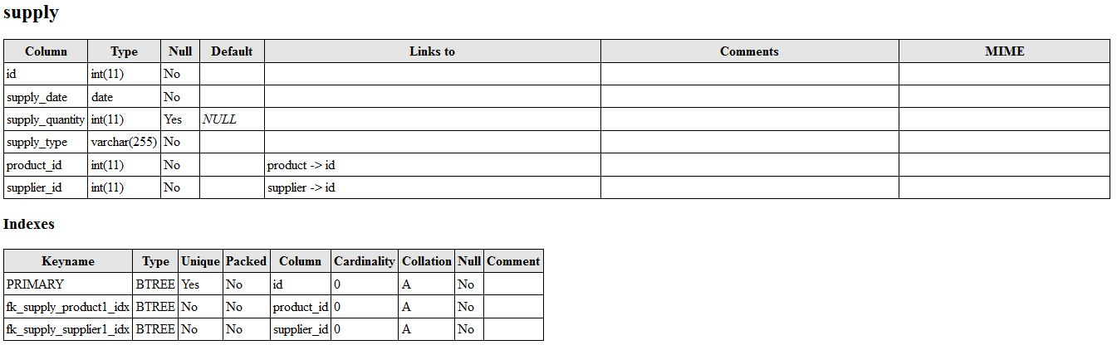

1. Screen Design

